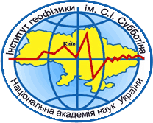
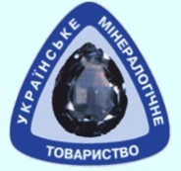
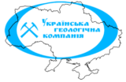
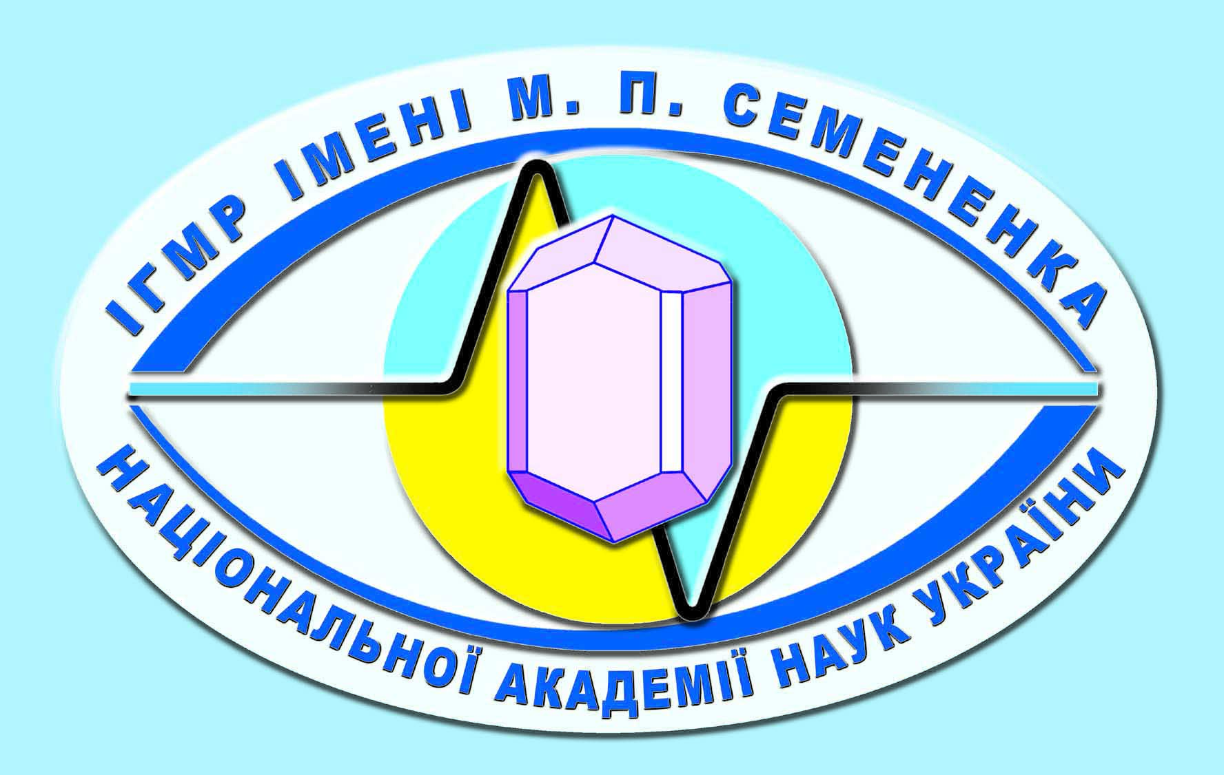

M.P. Semenenko Institute of Geochemistry, Mineralogy and Ore Formation of the National Academy of Sciences of Ukraine
S.I. Subbotin Institute of Geophysics of the National Academy of
Sciences of Ukraine
Mineralogical Society of Ukraine

SE Ukrainian Geological Company
Ukrainian Geological Survey

GEOLOGICAL STRUCTURE AND
MINERAL DEPOSITS
OF UKRAINE

October 12-13 2022, Kyiv, Ukraine

Dear colleagues!
We are pleased to invite you to the all-Ukrainian Scientific Conference «Geological structure and mineral deposits of Ukraine ». The event will take place on October 12-13 2022 at M.P.Semenenko Institute of Geochemistry, Mineralogy and Ore Formation of the National Academy of Sciences of Ukraine in a mixed plenary-remote mode

Sections of the conference
- Geochemistry, Mineralogy, Petrology
- Geochronology and Stratigraphy
- Tectonics and Geodynamics

- Mineral Deposits

- Landscape geochemistry

Venue
M.P. Semenenko Institute of Geochemistry, Mineralogy and Ore Formation, National Academy of Sciences of Ukraine (IGMOF NAS of Ukraine), Acad. Palladina ave. 34, Kyiv, Ukraine, 03142
Languages
Ukrainian, English. Oral report duration – 15 min and 5min – for questions and answers. Translation is not provided.
Technical support
A multimedia projector will be available for demonstrations of media presentations in *.ppt format in plenary mode. In remote mode demonstrations of media presentations will be available by use of ZOOM program.
Accommodation
You can use the website https://www.booking.com/city/ua/kiev.html to search, compare and book hotel rooms. If you need official invitation please sent your request to the Organizing Committee.

Important dates
10 September 2022 – Registration deadline
10 September 2022– Abstract submission deadline
02 October 2022 – Conference Program mailing
12-13 October 2022 – Conference

Necessarily! To do registration, please, submit filled application form: https://docs.google.com/forms/d/e/1FAIpQLSdQtsQCrjeJE0UY6xrWCpQZjO_bbNXIIe2iDyrL6oAIDjctbw/viewform?usp=sf_link

Conference Organizing Committee
Chairman of the Organizing Committee:
Ponomarenko O.M. – Academician of the NAS of Ukraine, Academician-Secretary of the Earth Sciences Department of the NAS of Ukraine, Director of the IGMOF NAS of Ukraine
Co-chair of the Organizing Committee:
Stepanyuk L.M. – Corresponding Member of NAS of Ukraine, Deputy Director of IGMOF NAS of Ukraine

Secretary of the Organizing Committee:
Vovk K.V. – Candidate of Geological Sciences, Deputy Director of IGMOF NAS of Ukraine

Members of the Organizing Committee:
Artemenko G.V. – Doctor of Geological Sciences, Head of the Department of Geology and Chronostratigraphy of the Precambrian, IGMOF NAS of Ukraine, Kyiv, Ukraine
Bezvynnyi V.P. - Candidate of Geological Sciences, chief geologist SE Ukrainian Geological Company
Gintov O.B. - Corresponding Member of NAS of Ukraine, IGP NAS of Ukraine
Donskoy N.A. – Candidate of Geological Sciences, Senior Researcher, IGMOF NAS of Ukraine

Kryuchenko N.O. – Doctor of Geological Sciences, Head of the Department, IGMOF NAS of Ukraine
Kulchytska H.O. – Doctor of Geological Sciences, Chief Researcher, IGMOF NAS of Ukraine, President of Mineralogical Society of Ukraine
Kuraieva I.V. – Doctor of Geological Sciences, Head of the Department, IGMOF NAS of Ukraine
Kryvdik S.G. – Doctor of Geological and Mineralogical Sciences, leading researcher IGMOF NAS of Ukraine, Kyiv, Ukraine
Orlyuk M.I. - Doctor of Geological Sciences, Head of the Department, IGP NAS of Ukraine
Pavlov G.G. - Candidate of Geological and Mineralogical Sciences, Senior Researcher, IGMOF NAS of Ukraine
Samborska I.A. – Candidate of Geological Sciences, Scientific Secretary of IGMOF NAS of Ukraine
Sukach V.V. – Doctor of Geological Sciences, Head of the Department, IGMOF NAS of Ukraine
Syomka V.O. – Doctor of Geological Sciences, Chief Researcher, IGMOF NAS of Ukraine

Working Group of the Organizing Committee
Chairman of the Working Group of the Organizing Committee:
Kovalenko N.O. – Junior Researcher, IGMOF NAS of Ukraine
Members of the Working Group of the Organizing Committee:
Antonenko T.S. – Candidate of Geological Sciences, Researcher, IGMOF NAS of Ukraine
Gulko V.V. – PhD student, IGMOF NAS of Ukraine
Zayats O.V. – Candidate of Geological Sciences, Researcher, IGMOF NAS of Ukraine
Kovalenko O.O. – Junior Researcher, IGMOF NAS of Ukraine
Luneva I.M. – Candidate of Geological Sciences, Researcher, IGMOF NAS of Ukraine
Lunev Ye.S. – Candidate of Geological Sciences, Researcher, IGMOF NAS of Ukraine

Abstract submission
Abstract should not exceed 4 pages and sent as attached *.doc (*.docx) file by the email geologyuks@gmail.com to the Organizing Committee. The file should be titled in English by the name of the first author. In the case of sending of more than one abstracts by the same author each file should include serial number added to file name. Each author can submit only two files, where he is first in the list of authors. The number of submitted abstracts in co-authorship is not limited by the Organizing Committee.
Page format: А4 (21,0 х 29,7 cm), all fields are the same – 2 cm. A font: Times New Roman, the size of a font 14 pt, unit interval, no formatting and hyphenation. Be sure to specify the UDC. Abstract title, names of the authors, Company/Institute names are levelled on the centre. Abstract title is entered in bold, capital letters; below, author’s surname – in italics; Company/Institute, address (new line for each author), e-mail – general text font. A short abstract (500-600 characters) is placed before the main text. Text paragraphs should have a space of 1 cm and be levelled on width. Figures as drawing in lines images should be built into the text and submitted separately as *.tif or *.jpeg image files with a resolution of at least 300 dpi. References should be inserted in text as ordinal numbers in square brackets. The list of references is placed at the end of general text in alphabetical order (font size 12 pt); authors’ names – in italics. All accepted abstracts will be published in the author’s version.
To meet the requirements of abstract preparation you may use this template:
https://drive.google.com/file/d/1svJhrVFm4szAjxUStnrDCAlhATo4VWdN/view?usp=sharing
https://drive.google.com/file/d/1MNs56fhpjHUdlaA64S71YIxJ7XdjV604/view?usp=sharing
Abstracts collection as an electronic publication will be posted on the website of M.P. Semenenko Institute of Geochemistry, Mineralogy and Ore Formation of NAS of Ukraine.

Organizing fee
Registration fee is 200 UAH (face-to-face participation), 100 UAH (online and extramural participation). Special categories of payment: postgraduate students and students – 50 UAH. Conference registration fee covers expenses linked with conference organization.
Details for non-cash payment of the registration fee will be communicated to the conference participants in the appropriate invitation letters. A copy of the receipt or payment order for payment of the registration fee must be submitted to the Organizing Committee before the conference. As an exception, by personal arrangement, payment in cash is possible.

Please note that registration fee must be paid no earlier than receipt of admission confirmation to the conference participant.

The best reports of the conference participants will be recommended for publication in professional journals: «Mineralogical Journal (Ukraine)» (included to the List of professional publications of Ukraine, category A, and indexed in the international scientometric database Web of Science Core Collection) and «Geochemistry and ore formation» (included to the List of professional publications of Ukraine, category B).
If needed, an electronic version of the conference participant's certificate is provided.

Contacts:

e-mail: geologyuks@gmail.com

Contact persons:

Vovk Kateryna
tel.: +(38) 067-108-80-57

